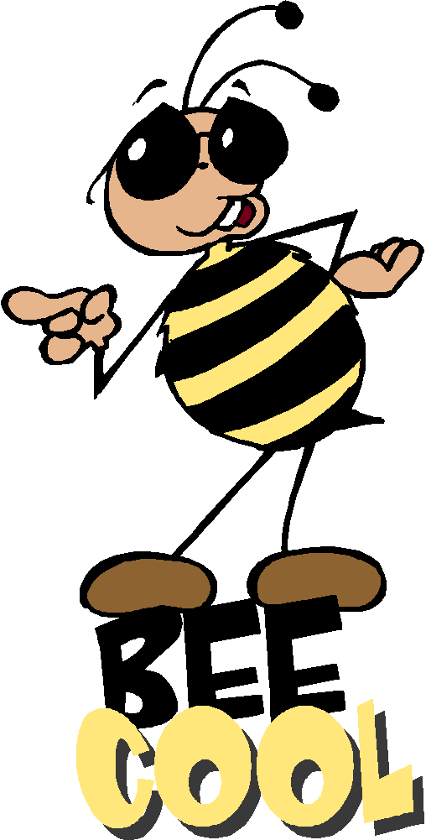
Sort 13 Spelling Words
Short e (CVC) and long e (CVCe and CVVC)

vest keep team been next sweep heat when jeep wheat web teeth clean dress sleep weak west week leaf

Spelling Test Friday on ten of your weekly spelling words, remember to study every night.

Sort 13 Spelling Words
Short e (CVC) and long e (CVCe and CVVC)

vest keep team been next sweep heat when jeep wheat web teeth clean dress sleep weak west week leaf

Spelling Test Friday on ten of your weekly spelling words, remember to study every night.

Sort 13 Spelling Words
Short e (CVC) and long e (CVCe and CVVC)

vest keep team been next sweep heat when jeep wheat web teeth clean dress sleep weak west week leaf

Spelling Test Friday on ten of your weekly spelling words, remember to study every night.

